Paper Structure and MLA Format
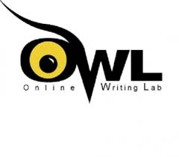
When writing a paper in my class use this format.
All information comes from Purdue Owl. To get to the main MLA format page use this URL: https://owl.english.purdue.edu/owl/resource/747/01/. Or you can visit their YouTube channel at: https://www.youtube.com/user/OWLPurdue.
Starting your paper:
To start you paper first go to “Format” at the top of the screen. In the drop down menu go to “Paragraph…” Once in the Paragraph menu set Indentions, Right and Left are set to 0”. Then under Spacing set Before and After to 0 pt. Then set Line Spacing to Double.

Next set up your header following these instructions. Aligning the text to the left put the following:
Your Name [Return]
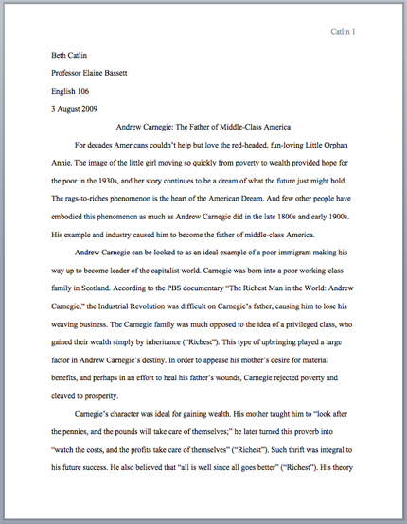
Teacher’s Name [Return]
Name of the Class [Return]
(Social Studies)
Date the paper is Due [Return]

Then “Center Text” and put the title of your paper.

Change back to Left Margin.

You are now ready to start typing your paper.

Here is an example of the first page of a MLA Format paper.

Basic Paper Structure:
This structure should be used whether you are writing a report or persuasive piece.
Any paper can be organized into three easy categories:
- Intro
  - This is where you should introduce the topic of your paper and give important general details. Your thesis needs to be in this paragraph and should be easy to identify.
- Body
  - This will take up the majority of space/writing in your paper. The body is where you give important pieces of information related to your thesis. You will also need to elaborate or explain why the evidence is important, how it prove your thesis or explain to provide better understanding. The elaboration you give will depend on the type of paper you are writing.
  - A body paragraph has 4 essential pieces that are needed.
    - Topic Sentence/Argument
      - The first sentence in your paragraph that gives the topic of the paragraph to follow.
    - Evidence
      - Facts that are given to prove your topic/argument and thesis.
    - Elaboration
      - Where you explain your evidence. Why does your evidence matter? How does your evidence prove your thesis? Give details to help the reader understand.
    - Conclusion Sentence
      - Your final sentence that re-explains the main purpose of your paragraph and main thesis. This sentence is very important to adding a persuasive voice so be very direct in your statement.
- Conclusion
  - This paragraph is where you sum up the entirety of your thesis or purpose. This paragraph should be more specific than your intro.
In-text citations:
Anytime you use information in your paper that is not an original thought, quoted or paraphrased, must have an in-text citation. Below is an example with a sentence and an in-text citation at the end.
Romantic poetry is characterized by the "spontaneous overflow of powerful feelings" (Wordsworth 263).
How to cite your paper:
Here is the basic guideline for citing any source in MLA:

- Author.
- Title of source.
- Title of container,
- Other contributors,
- Version,
- Number,
- Publisher,
- Publication date,
- Location.

Each element should be followed by the punctuation mark shown here.
Here are some citations for commonly used sources:
For a book:

Author’s Last Name, First Name. Title of Book. Place of Publication, Publisher, Publication Date.
For a periodical (magazines, newspapers, and scholarly journals):

Author(s) Last, First. "Title of Article." Title of Source, Volume, Issue, Year, pages.

For a electronic source:
Here are some common features you should try to find before citing electronic sources in MLA style. Not every Web page will provide all of the following information. However, collect as much of the following information as possible both for your citations and for your research notes:
- Author and/or editor names (if available)
- Article name in quotation marks.
- Title of the website, project, or book in italics.
- Any version numbers available, including editions (ed.), revisions, posting dates, volumes (vol.), or issue numbers (no.).
- Publisher information, including the publisher name and publishing date. – Usually at bottom of page.
- Take note of any page numbers (p. or pp.) or paragraph numbers (par. or pars.).
- URL (without the https://) DOI or permalink.
- Date you accessed the material (Date Accessed)—While not required, it is highly recommended, especially when dealing with pages that change frequently or do not have a visible copyright date.
- Remember to cite containers after your regular citation. Examples of containers are collections of short stories or poems, a television series, or even a website. A container is anything that is a part of a larger body of works.
Use the following format:
Author. Title. Title of container (self contained if book), Other contributors (translators or editors), Version (edition), Number (vol. and/or no.), Publisher, Publication Date, Location (pages, paragraphs and/or URL, DOI or permalink). 2nd container’s title, Other contributors, Version, Number, Publisher, Publication date, Location, Date of Access (if applicable).
Example of electronic source:
Felluga, Dino. Guide to Literary and Critical Theory. Purdue U, 28 Nov.
2003, www.cla.purdue.edu/english/theory/. Accessed 10 May 2006.

Here is an example of a Works Cited page:
Always start a Works Cited on new page.
Works Cited
Dean, Cornelia. "Executive on a Mission: Saving the Planet." The New York Times, 22 May 2007, www.nytimes.com/2007/05/22/science/earth/22ander.html?_r=0. Accessed 12 May 2016.
Ebert, Roger. Review of An Inconvenient Truth, directed by Davis Guggenheim. rogerebert.com, 1 June 2006, www.rogerebert.com/reviews/an-inconvenient-truth-2006. Accessed 15 June 2016.
Gowdy, John. "Avoiding Self-organized Extinction: Toward a Co-evolutionary Economics of Sustainability." International Journal of Sustainable Development and World Ecology, vol. 14, no. 1, 2007, pp. 27-36.
An Inconvenient Truth. Directed by Davis Guggenheim, performances by Al Gore and Billy West, Paramount, 2006.
Leroux, Marcel. Global Warming: Myth Or Reality?: The Erring Ways of Climatology. Springer, 2005.
Milken, Michael, et al. "On Global Warming and Financial Imbalances." New Perspectives Quarterly, vol. 23, no. 4, 2006, p. 63.
Then information for this sheet came from Purdue Owl.
Russell, Tony, et al. "MLA Formatting and Style Guide." The Purdue OWL. Purdue U Writing Lab, Accessed 2 Aug. 2016.

For further information on MLA format go to: https://owl.english.purdue.edu/owl/resource/747/01/
Or visit their YouTube Channel:
https://www.youtube.com/user/OWLPurdue

